How to build a R package in Rstudio?

1. Call ***library(usethis)***
   1. Use function ***create_package(“~/dir/package_name)”*** 🡪 it generates all required files that will be used in the R package and will jump into a new session.

Package: QCRegistry

Title: Data quality check package for BC Cancer Registry bi-weekly update files

Version: 0.1.0 **🡪 it starts with 0.0.0.9000 and then 0.0.0.9001, 9002 until we have a minor release**

Authors@R:

person(given = "Shan",

family = "Wang",

role = c("aut", "cre"), **🡪 cre is the maintainer and aut is the author, i.e., contributed some functions**

email = "szwang@bccrc.ca",

comment = c(ORCID = "YOUR-ORCID-ID"))

Description: This R package contains funtions to check quality of data that OVCARE received bi-weekly from BC Cancer Registry. It serves as the first line of 'border inspection' in the whole clinical outcome project. A total of 42 rules defined in this package and records pass all quality checking rules will then be processed for the next step, i.e., be merged into the SQlite database on /H: Drive. There will be dashboard and csv file generated for those failed ones. They will be given back to the data provider for further investigation.

License: MIT + file LICENSE **🡪 library(usethis) has a function called use_mit_license(copyright_holder=”OVCARE”)**

Imports:

datacheck,

dplyr,

here,

lubridate,

tidyverse,

tidyr,

reshape2,

knitr,

purrr,

stringr

Encoding: UTF-8

LazyData: true

Roxygen: list(markdown = TRUE)

RoxygenNote: 7.1.1

1. Open a new R script file and following roxygen2 format to add a new function. Each .R file contains one function

#' Function to prepare registry data before applying QC checking. **🡪 always starts with #’**

#' @export **🡪 this makes this function available from documentation**

#' @param all.patients dataframe of the received registry data **🡪 this is for function documentation when people run ?function_name**

#' @importFrom dplyr %>% **🡪 import other functions from other packages**

#' @importFrom dplyr mutate

#'

#' @return Two dataframes: one for alive patients and another one for deceased patients. **🡪 also documentation when people run ?function_name**

1. Check and build

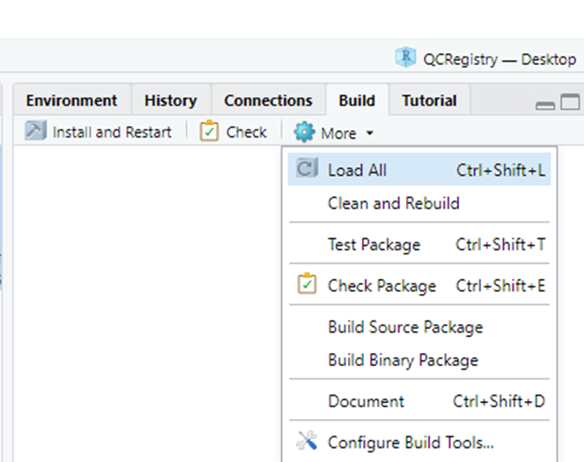

**Check** to check everything before building the package

**Install and Restart** to build the package locally

**Build Source Package** builds the .tar.gz package